Name_____________________________________________________Period_____Assignment #_____
What Determines Sex Ratio Chi Square (χ²) Analysis
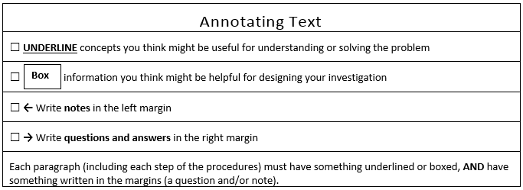
Prelab: Annotate the introduction and answer questions 1-7

The chi square statistic is used to test whether or not categorical data are different from expected. For example, if you flipped a coin 10 times, you would expect it to be heads 5 times and tails 5 times. However, we know this doesn’t always happen. If I flipped a coin 10 times and got heads 7 times and tails 3 times, should I question the way I am flipping the coin, or the way the weight of the coin is distributed, or some other variable involved with coin flipping? Let’s say I think my coin has more weight on the tails side causing heads to come up more often than the 50-50 expectation. This would be my H_{A}, or alternative hypothesis. The chi square test tells us whether or not we can reject the H₀, which is the null hypothesis. The null hypothesis means that the observed difference is not different than expected (the 50-50 expectation). If we can reject the H₀, then we can accept the H_{A}. However, just because we can reject the H₀, it doesn’t follow that the H_{A} is correct. If my H_{A} is the coin is weighted incorrectly, there could be some other reason for the difference for which my experimental design failed to control.
There are innumerable things, or variables, that can affect complex systems like the probability of flipping a coin and getting heads or tails. You know this intuitively because you probably wouldn’t be surprised if you flipped a coin 10 times and got heads 7 times and tails 3 times. If we accept the H₀, we are saying that the difference in the experimental results from the expected results is zero. This means the difference is due to chance, which is the sum total of all the variables that can or could affect the system. In this example, the system is flipping a coin.
There are 2 types of statistical mistakes called type I and type II errors. A type I error is a false positive, and a type II error is a false negative. For example, a type I error is rejecting H₀ when the H₀ really is true. This is a false positive. In the coin flipping example, I commit a type I error if I say the difference is not due to chance when in fact it is. If I accept the H₀ hypothesis and the H₀ hypothesis is false, then I have committed a type II error. This is called a false negative. In the coin flipping example, I commit a type II error if I say the difference is due to chance when in fact my coin is weighted. Scientists don’t want to make either error. There is an excepted compromise for balancing false negatives (type II errors) with false positives (type I errors). When the probability of a type II error is less than 5%, we say the difference in the experimental results from the expected results is statistically significant. Another way to think about this compromise is if we ran the exact same experiment 20 times we would expect to get the false positive (type I error) 1 time. This explains why there is conflicting research about health and every other messy subject, and why you can find research to support just about any health claim.
Let’s see if flipping a coin and getting heads 7 times and tails 3 times is likely due to chance alone. In this example, we only have one independent variable (a coin) and 2 possible outcomes (heads or tails), which are the dependent variables. The number of possible outcomes is called the degrees of freedom. This is calculated by adding up all of the possible outcomes and subtracting by 1. In this example we can get heads or tails, so our degrees of freedom is 2-1=1.
H₀ = The difference in number of heads and tails is due to chance.
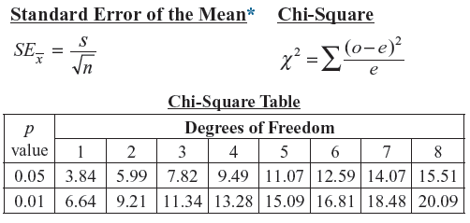
H_{A} = The difference in number of heads and tails is due to a weighted coin.
You will be given the information in figure 1 on the AP exam. You will need to be able to calculate the chi square statistic and interpret the results. The p-value is the probability the results are due to chance. We accept the H₀ unless the probability of making a type II error is less than 0.05 or 5%. This is an arbitrary significance level. The lower we set the level, the more likely it is for us to make a type II error, but this also decreases the probability of making a type I error: rejecting the H₀ when is it true.
Figure 1
Below is the calculation of the chi square statistic.

$$x=\sum{\frac{{(o-e)}^{2}}{e}=\frac{{(7-5)}^{2}}{5}+\frac{{(3-5)}^{2}}{5}=1.6}$$
1.6 is less than 3.84. This means the probability of getting heads 7 times out of 10 is greater than 5%, so we accept the H₀. The results are due to chance alone.
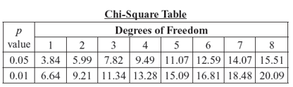

Below is a table that can be used for calculating the chi square statistic.
Chi square calculation
 | Observed (o) | Expected (e)
Heads
Tails
+
________

Problems
- Calculate the chi square statistic for flipping a coin 20 times and getting heads 14 times.

- Explain the results from the previous question in terms of H₀, H_{A}, and the p-value.

- Calculate the chi square statistic for flipping a coin 30 times and getting heads 21 times.

- Explain the results from the previous question in terms of H₀, H_{A}, and the p-value.

- In all three examples, you got heads 70% of the time. What does this tell you about the importance of sample size in an experiment?

Fitness describes individual reproductive success and is equal to the average contribution to the gene pool of the next generation that is made by individuals of the specified genotype or phenotype. It turns out that fitness is a bit more complicated than this textbook definition. From the gene's point of view, evolutionary success ultimately depends on leaving behind the maximum number of copies of itself in the population. This fact leads to prosocial selective pressure because an individual’s fitness also includes the number of offspring equivalents it rears, rescues or otherwise supports through its behavior. This is called inclusive fitness. Your children will have a copy of 50% of your genes and your grandchildren will have a copy of 25% or your genes. This means having grandchildren increases your fitness. In terms of fitness, two grandchildren are just as good as 1 child. This logic (with different relatedness percentages) applies to sisters, brothers, nieces, nephews, and cousins as well.
Inclusive fitness has resulted in strong selective pressure for behaviors that increase parental investment in offspring. Parental investment, in evolutionary biology and evolutionary psychology, is any parental expenditure (e.g. time, energy, resources) that benefits offspring. If female offspring are more likely to produce more grandchildren than male offspring, there would be selective pressure for giving birth to more females. The same would be true if males were more likely to produce more grandchildren. If there was a bigger payoff (more grandchildren) by investing in female children than male children, there would be selective pressure for behaviors that caused more investment in female offspring than male offspring and vice versa. Depending on a wide variety of conditions, females or males may be more likely to produce more grandchildren, so we should be able to hypothesize what these conditions are and find sex ratio manipulation and/or unequal parental investment when those conditions are met in nature.
Am Nat. 2004 Jan;163(1):40-54. Epub 2004 Jan 14.

Maternal dominance, maternal condition, and offspring sex ratio in ungulate mammals.
Sheldon BC¹.

Author information
¹Edward Grey Institute, Department of Zoology, University of Oxford, South Parks Road, Oxford OX1 3PS, United Kingdom. ben.sheldod@zoology.oxford.ac.uk

Abstract
Trivers and Willard's suggestion that natural selection favors maternal control of offspring sex ratio in relation to maternal condition has been much debated. The theoretical plausibility of the idea, under some conditions, is firmly established, and there is strong empirical support for conditional sex allocation in some taxa. However, the extent to which this hypothesis can be applied to mammals, particularly ungulates, has been more controversial. We used meta-analysis to review published studies of the Trivers-Willard hypothesis within ungulates and to assess the overall level of empirical support for the hypothesis. Overall, data from 37 studies of 18 species suggested a weak but significant positive correlation between maternal condition and sex ratio (r=+0.09). However, average effect size differed markedly between different categories of studies. Studies using measures of maternal condition that were taken preconception and on the basis of behavioral dominance provided strong evidence for a relationship between maternal condition and the sex ratio (r=+0.17-0.25). In contrast, studies that used morphological or physiological measures of condition that were measured postconception provided little or no evidence for a relationship between maternal condition and sex ratio (r=+0.05-0.06). There are several reasons to suggest that data collected postconception and relying on morphological measures of condition are less likely to capture variables that cause selection for biased sex allocation. In addition, we found that the relationship between sex ratio and maternal condition depended on life-history characteristics; relationships were stronger when sexual size dimorphism was more male biased and when gestation periods were longer. Overall, our analyses suggest that data from ungulates are consistent with the Trivers-Willard hypothesis but only when appropriate measures are used.
You are studying the possibility that dominance influences male to female sex ratio in a species of primate. In this species, the males leave the group before sexual maturity and attempt to find other groups to join. Joining new groups is dangerous and frequently results in injury or death of the male. Females tend to inherit their mother’s status. High status results in greater reproductive success. Based on Trivers and Willard’s suggestion that natural selection favors maternal control of offspring sex ratio, would a dominant female be more, less, or equally likely to have female offspring?
- Prediction

- Explanation for your prediction

Procedure:
Selecting a bead represents a birth from a dominant female primate
- Without looking, select a bead from the cup. Red = male and white = female
- Record the result below
- Replace the bead and thoroughly mix
- Repeat steps 1-3 nine times
- Perform a chi square analysis
- Repeat steps 1-5 using a sample size of 100 instead of 10

Independent variable =

Dependent variable =

H₀ =
H_{A} =
Degrees of freedom (df) =

Chi square calculation
 | Observed (o) | Expected (e)
Males
Females
+
________

 | 10 Births | Total
Male
Female

- Explain what the results mean in terms of the H₀ and H_{A} hypotheses, and the p-value

 | 100 Births | Total
Male
Female

Chi square calculation
 | Observed (o) | Expected (e)
Males
Females
+
________

- Explain what the results mean in terms of the H₀ and H_{A} hypotheses, and the p-value

- Explain any differences between the 2 experiments

Your Task:
Imagine you are an evolutionary psychologist and are interested in studying maternal sex manipulation of offspring. You will use the same method as you did above, but first imagine how you would conduct a real experiment in nature. Answer the following questions to help you design a controlled experiment.
- Organism

- Come up with a possible condition (environmental or social) that could result in selective pressure for the evolution of maternal manipulation of sex ratio other than the one you just modeled.

- A hypothesis is a testable and falsifiable explanation for the cause of a phenomenon. You can also think of a hypothesis as an answer to a causal question. Answer the following question: What determines sex ratio?

- Variables you need to control for

- Variables you can’t control for

- Control condition

- Independent variable

- Dependent variable

- What data will you collect

- Prediction

- How will you organize your data
ADI Investigation Proposal TGB Version
What data will you collect?

How will this data help you answer the guiding question?

What safety precautions will you follow?
Claim:

Method:
Guiding Question:

Alternative claims:

Data:

Guiding Question: What determines sex ratio?
Our Claim:

Our Evidence:
Our Justification of the Evidence:
Analysis: break it down (Illustrate and describe your data)
Interpretation: What does the analysis mean?
Use your scientific knowledge and analysis to support your interpretation

