Name______________________________________________Period_____Assignment #_____

Diffusion and Osmosis: What is the solute potential of potato cells?

- What were some strengths of the way you planned or carried out your investigation? (What made is scientific?)

- What were some weaknesses of the way you planned or carried out your investigation? (What made it less scientific?)

- What rules should we make in order to ensure that our next investigation is scientific?

- The mass of the ‘cell’ is 11 grams. Is this an observation or inference?

- The mass of the ‘cell’ increased 2 grams. Is this an observation or inference?

- Water moved into the cell. Is this an observation or inference?

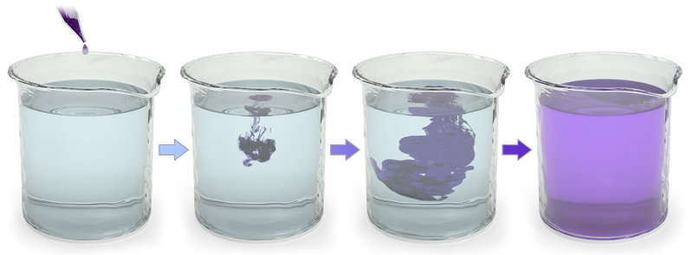
- Describe what happened

- Explain why diffusion happens (address energy in your explanation)
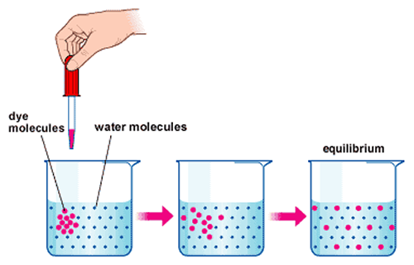

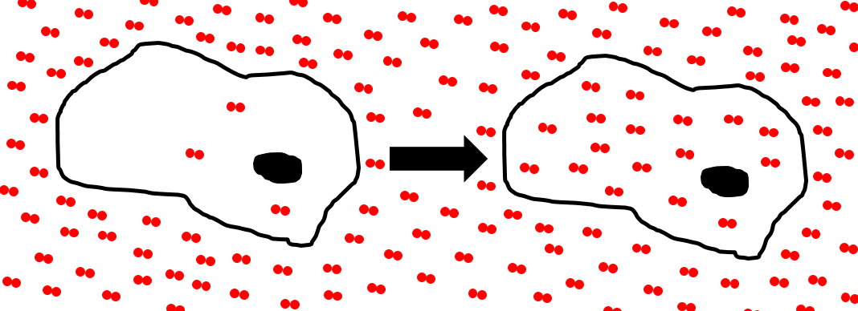
- Describe what happened
Time

- What is this process called?

- Explain why this did or did not cost the cell energy

- What properties can you infer the solute has?

- Explain why substances with these properties are permeable to the plasma membrane

- What kind of transport is shown in figure (a)?
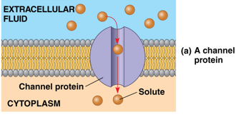
- How do you know?

- What kind of transport is shown in figure (b)?
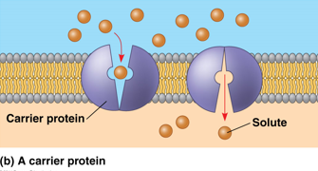
- How do you know?

- Explain why this did or did not cost the cell energy

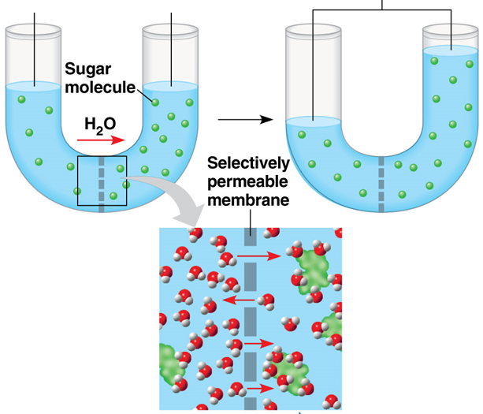
- Describe what happened

- What is this process called?

- What kind of transport is this?

- Why did the water rise?

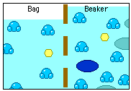
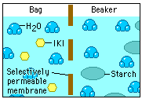
- Describe what happened?

- Explain why it happened?

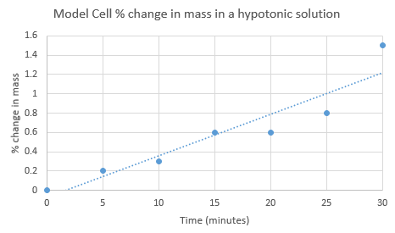
- Calculate the rate of water moving into the cell at 7 minutes. Show your work!

- Calculate the rate of water moving into the cell at 22 minutes

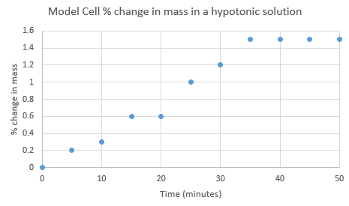
- Calculate the rate of water moving into the cell at 40 minutes

- Describe and explain the movement of water over the 50 minutes of data collection

- Explain why the percent change was used rather than change in mass

- Calculate the percent change in mass for the following experimental results: model cell 1 = 7.3g initial, 8.6g final; model cell 2 = 17.4 initial, 14.9 final

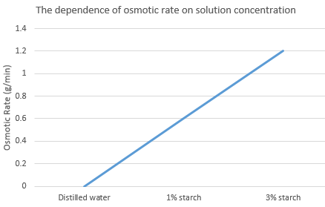
- What is the rate of osmosis in the following:
- Distilled water

- 1% starch solution

- 3% starch solution

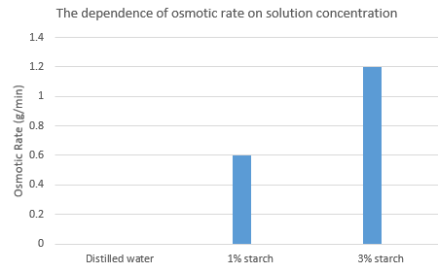

- Which chart best represents the data? Explain your reasoning.

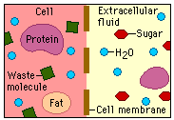
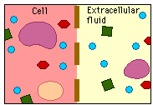
- Describe what happened?

- Explain why it happened?

- Explain how sugar got into the cell and why it did or did not cost the cell energy

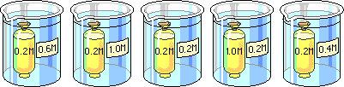
- Arrange the beakers above in order of mass inside of them after 30minutes. Starting with the one with the least amount of mass. (assume they all start with the same amount of mass)
- Explain the relative position of each beaker

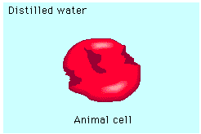
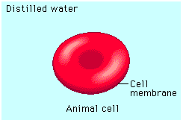
- Describe what happened

- Explain why it happened

- What would happen if a human drank ocean water?

- Predict the net movement of water

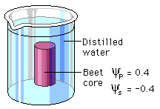
- Justify your prediction. A justification has 3 components: 1) scientific knowledge and/or theory; 2) specific data from your analysis related to the knowledge; and 3) an explanation of HOW the data supports the knowledge.

- Calculate the water potential for the beet core above

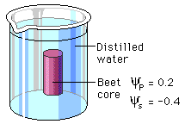
- Calculate the water potential for the beet core

- The concentration of solutes in a cell is 0.5M. Calculate the solute potential of the cell at 23°C.

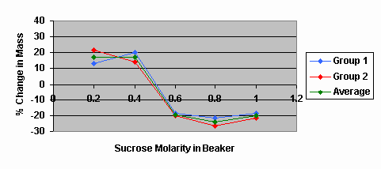
- The experiment below was conducted at 15°C. Calculate the solute potential of potato cells.

- Provide reasons for the results at the various solute concentrations. Your answer must include the following words: turgor pressure, water potential, dynamic equilibrium, isotonic, hypertonic, hypotonic, and plasmolysis

- How was the following demonstrated in this lab?
Patterns
- Different patterns may be observed at each of the scales at which a system is studied and can provide evidence for causality in explanations of phenomena.

- How was the following demonstrated in this lab?
Cause and effect: Mechanism and Prediction
- Empirical evidence is required to differentiate between cause and correlation and make claims about specific causes and effects.
- Cause and effect relationships can be suggested and predicted for complex natural and human designed systems by examining what is known about smaller scale mechanisms within the system.

- How was the following demonstrated in this lab?
Systems and system models
- Models (e.g., physical, mathematical, computer models) can be used to simulate systems and interactions—including energy, matter, and information flows—within and between systems at different scales.
- Models can be used to predict the behavior of a system, but these predictions have limited precision and reliability due to the assumptions and approximations inherent in models.

- How was the following demonstrated in this lab?
Energy and matter: Flows, Cycles, and Conservation
- The total amount of energy and matter in closed systems is conserved.
- Changes of energy and matter in a system can be described in terms of energy and matter flows into, out of, and within that system.
- Energy drives the cycling of matter within and between systems.

- How was the following demonstrated in this lab?
Structure and Function
- The functions and properties of natural and designed objects and systems can be inferred from their overall structure, the way their components are shaped and used, and the molecular substructures of its various materials.

