Questioners Questioning Questions

Our imagination is stretched to the utmost, not as in fiction, to imagine things which are not really there, but just to comprehend those things which are there.
Richard Feynman
If you don’t have more questions after you engage in a learning activity than when you started, you haven’t learned anything.
Question Types:
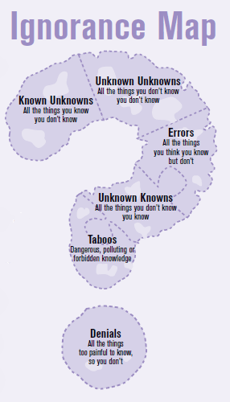
- Basic science knowledge: these are questions that can be answered by looking up facts in your notes or on Wikipedia (They should never be on your list).
Examples: What part of the brain is most responsible for attention? What are the plantar flexor and dorsi flexor muscles that move the foot?
- Application
Examples: What would happen if the level of dopamine decreased in the striatum? How does the stride and cadence of a runner affect musculoskeletal health?
- Societal
Examples: Is technology use affecting the way people think? Why are epidemiologists concerned about decreases in vaccination rates?

What you know
What you know
The size of the perimeter represents what you know you don’t know
The area of the circle represents what you know
What you know you don’t know keeps getting bigger!
What you know
What you know increases as you learn. Somewhat paradoxically, what you know you don’t know increases as well!

