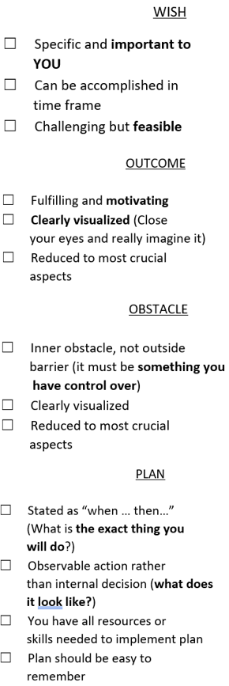
Name Click or tap here to enter text. Period Click or tap here to enter text. Assignment # Click or tap here to enter text.
WOOP Reflection and Update
My career goal is: Click or tap here to enter text.
- Reread your previous WOOP
- In the space below, reflect on the following:
Rate your progress towards your wish on a scale of 1 to10 and provide reasons for your rating
Click or tap here to enter text.
Describe an obstacle you overcame and explain how you did it, or describe an obstacle you failed to overcome and explain why you failed
Click or tap here to enter text.
Explain what you will do to improve
Click or tap here to enter text.
Wish:
Your wish must be aligned to your career goal and accomplishable within 2 to 3 weeks
Click or tap here to enter text.
Outcome:
Your outcome must be intrinsically motivated.
Click or tap here to enter text.
Obstacle:
Click or tap here to enter text.
Plan:
Click or tap here to enter text.

